"My Mama always said, 'Life was like a box of chocolates; you never know what you're gonna get." (Forest Gump)

Welcome to Video Production 2 !! This class will build upon what was taught in Video 1 as well as add additional information in the filming process. Students will also learn about producing programs and news shows as well as all the equipment involved. I am excited about this year because we now have a lab and a studio to work in and produce our shows. A lot of what we do will then air on Channel 19 with Charter Cable. Students will have to put in a lot of time filming and editing after school to create their projects.

Syllabus For Video Production 2:
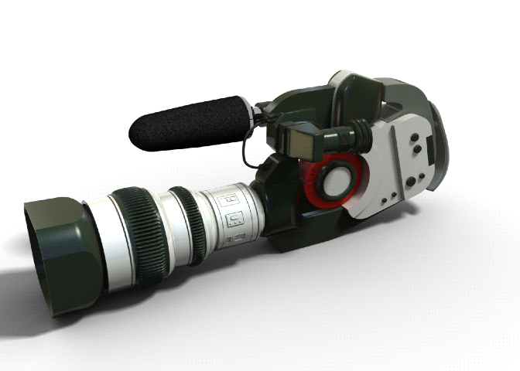




This list is subject to change based on needs of school district.
- Review Camera Angles and editing
- Learn how to write scripts
- Learn how use lighting in film
- Learn the various equipment for a live production
- Learn how to use sound in film
- Learn how to create a live production/news show
- Learn how create a short film
- Learn how to use an titling program
- Learn how to use a dvd making program
- Create a music video
- Create a public service announcement
- Create a promotional video for a class

Required Supply List:
1 inch 3 ring binder to keep in room
Pencil/Pen to keep in room
Password and login for Blackboard
1GB Flash Drive or Larger is recommended
1 tape per group will be provided, they can be purchased for $3.00 after that.

Other Requirements:

Students will are required to film one event per trimester with a partner: games, after school activities, speakers and other events off campus. Sometimes students will be required to film during the school day and will be excused from class. If a student doesn’t complete the event they signed up for, a “0” will be given for the event grade.

Students will also be required to keep a journal of ideas and proposals through out the class. This journal will be collected and graded.

Students will be required to help set up for different events and to help put equipment away. Some equipment is heavier than others, so they need to make accommodations.

"Toto, I've a feeling we're not in Kansas anymore."(The Wizard of Oz)

Expectations:

I expect all students to be responsible with equipment and they will be subject to paying for replacements or repairs if broken in their care (see equipment parent permission form).




I expect all equipment to be returned first thing in the morning to the lab. Privileges will be lost of this is not followed

I expect all students representing Linden Schools during their filming to be respectful, cooperative and courteous to everyone they come in contact with. Failure to do this could result in loss of using equipment or failure of the class.

I expect students to stick with their groups until a project is completed. I expect students to work on solving conflicts in a constructive manner during projects and to work cooperatively until they are finished. I will not try to find another group for you to join after the project has started.

I expect every student to be involved in the production process of a project. Every one is required to act, direct, edit, write, etc in the process of completing a project. No one person should take over and do everything in a group. I give a participation grade for each project.

I expect all students to listen during lecture, to work hard on projects and to try all roles in a video.

"Keep your friends close, but your enemies closer." (The Godfather II)
Class Room Rules:
1. Please leave all pop, food and candy in your locker. Water is acceptable to have in class, but must not be near any equipment.

2. If you want to leave the room, please bring your planner to class. Students who leave their planner in their locker will be given a pass along with a tardy in cases of emergency.

3. Please be in the classroom and ready to work when the bell rings. Students are allowed 3 tardies and the 4th will result is Saturday School.

4. Please refrain from using obscene language in the classroom or projects.

- Please be respectful of everyone and everything. If you want to be respected you need to the respect.

- No Cell Phones

- Follow all Directions.

Grade determination




Final grades are determined by their participation on projects, classroom work/projects, homework, final exam, and completion grades. Project requirements will include:
Content - Does your video fit the assignment? Does it give all the info? Is it Appropriate? etc.
Editing - Does you video flow? Is it choppy? Does the sound fit with the voices? etc.
Use of notes and information- Did you include the correct information from class? Did you explain if an explanation was needed?
Participation - Did you work on the video in every aspect, beginning to end? Did I see you do this?
Completion - Did you turn your video in on the due date? Or was it a few days later? Projects need to be turned in on time. A due date and you will be required to meet the due date for full credit of completion points. Example: Turned in on due date full 30 pts. 1 day late 25/30. 2 days late 20/30. 3 days late 15/30. And so on

"I'm king of the world. "(Titanic)

Grading Scale

100-93% = A
90-92 = A-
88-89 = B+
83-87 = B
80-82 = B-
78-79 = C+
73-77 = C
70-72 = C-
68-69 = D+
63-67 = D
60-62 = D-

**There will be a semester exam for all students. The exam will cover material covered in class.


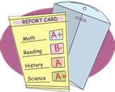
**Semester grades are determined by: 80% work in semester, 20% final exam

**The grade you are given will be the grade that you earned. Your effort and participation will be reflected in your grade.

"Remember George, No man is a failure who has friends. ... You see, George, you really have had a wonderful life" (It's a Wonderful Life)

